Operational Concept Description (OCD)

XL2

Team No: 10

Name | Primary Role | Secondary Role
Kevin Crimi | Prototyper, Builder | Feasibility Analyst
Sindhu Nachimuthu | Project Manager,  Life Cycle Planner | Builder
Ritesh Nanda | Operations Concept Engineer | Reviewer, Tester, Trainer
Muthukumaran Dhanapal | Software Architect, Builder | Feasibility Analyst
Ted Lee | IIV & V, Tester, Quality Manager | Project Manager

Version History
Date | Author | Version | Changes made | Rationale
09/30/12 | Ritesh Nanda | 1.0 | - Original template | - Initial draft v1.0
10/10/12 | Kevin Crimi | 1.1 | - Added preface page numbering  - Added document name and revision date to the footer  - Added indices pages to table of contents  - Corrected Sec 1.1 Purpose of OCD  - Removed Venture capitalists from program model | - Fix defects detailed in VCP review
10/14/12 | Ritesh Nanda | 1.2 | - Revised benefits chain diagram  - Revised current business workflow diagram  - Revised system boundary diagram | - Fix defects detailed in VCP review
10/15/12 | Ritesh Nanda | 2.0 | - Completed 2.2 System Capability Description  - Completed 3.2.1 Capability Goals  - Completed 3.2.2 Level of Service Goals  - Completed 3.2.2 Organizational Goals  - Completed 3.2.4 Constraints  - Completed 3.2.5 Relation to Current System  - Completed 3.3 Proposed New Operational Concept  - Completed 3.4 Organizational and Operational Implications | - Core FC Package artifact
10/15/12 | Kevin Crimi | 2.1 | - Fixed headings and footers | - Updated for FC Draft submission
10/30/12 | Ritesh Nanda | 2.2 | - Added functionalities in System Boundary Diagram  - Updated 1.1 Purpose of System  - Updated Business Case Diagram  - Updated Program Model  - Updated 3.1.2 Artifacts  - Revised 2.3 System Boundary  - Removed 3.2.2 Levels of Service Goals  - Updated 3.2.1 Capability Goals | - Updated for FCR ARB
10/31/12 | Ritesh Nanda | 2.3 | - Edited 3.3.2 Business workflows  - Updated 3.1.2 Artifacts as per Win Book  - Updated 3.2.1 Capability Goals as per win book  - Updated Levels of service Goals as per win book  - Updated 3.3.1 ER Diagram | - Fix defects detailed in FCP review
11/04/12 | Ritesh Nanda | 3.0 | - Updated 1.2 Status of OCD  - Updated Program Model  - Updated 2.3 System Boundary & Environment Diagram as per Win book MMF  - Updated 3.1.2 Artifacts  - Updated 3.1.3 Current Business workflow Diagram  - Updated 3.2.2 Organizational Goals  - Updated 3.2.4 Relation to Current System  - Updated 3.3.1 Element Relationship Diagram  - Updated 3.4.2 Operational Transformation | - Core DC Package Artifact
11/14/2012 | Ritesh Nanda | 3.1 | - Updated Section 2.2 System Capability Description | - Response to Evaluation of DC package
11/26/2012 | Ritesh Nanda | 4.0 | - Updated Section 3.1.3 Current Business Workflow | - Draft TRR Package
12/04/2012 | Ritesh Nanda | 4.1 | - Updated section 1.2 OCD Status | - Draft for TRR ARB Session

Table of Contents
Operational Concept Description (OCD) i
Version History ii
Table of Contents iii
Table of Tables v
Table of Figures vi
1. Introduction 1
1.1 Purpose of the OCD 1
1.2 Status of the OCD 1
2. Shared Vision 2
2.1 Benefits Chain 3
2.2 System Capability Description 5
2.3 System Boundary and Environment 6
3. System Transformation 7
3.1 Information on Current System 7
3.2 System Objectives, Constraints and Priorities 10
3.3 Proposed New Operational Concept 13
3.4 Organizational and Operational Implications 15

Table of Tables
Table 1: The Program Model 2
Table 2: Capability Goals………………………………………………………………………………………………………….9
Table 3: Relation to Current System 11

Table of Figures
Figure 1: Benefits Chain Diagram of XL2 Project 4
Figure 2: System Boundary and Environment Diagram of XL2 Project 6

Figure 3: Current Business Workflow……………………………………………………………………………………………8
Figure 4: Element Relationship Diagram 13
Figure 5: Business Workflow Diagram of XL2 Project………………………………..…………………………………….14

Introduction

Purpose of the OCD
- The purpose of OCD in XL2 project is to identify the stakeholders critical for the project’s success.
- The success critical stakeholders for our project are:
    - Client Eric Lev
    - Development team
- This document is created by XL2 Development team and would be maintained by it only till the final deployment of the project.

Status of the OCD
The OCD is presently at TRR stage with version 4.1. Changes have been incorporated according to feedback received from the DC package and from the comments provided by the TAs/Graders in their independent review of the OCD document.

The document is being updated after every client meeting, internal team meetings, document review feedback, and various other client Interaction sessions if any change is warranted.

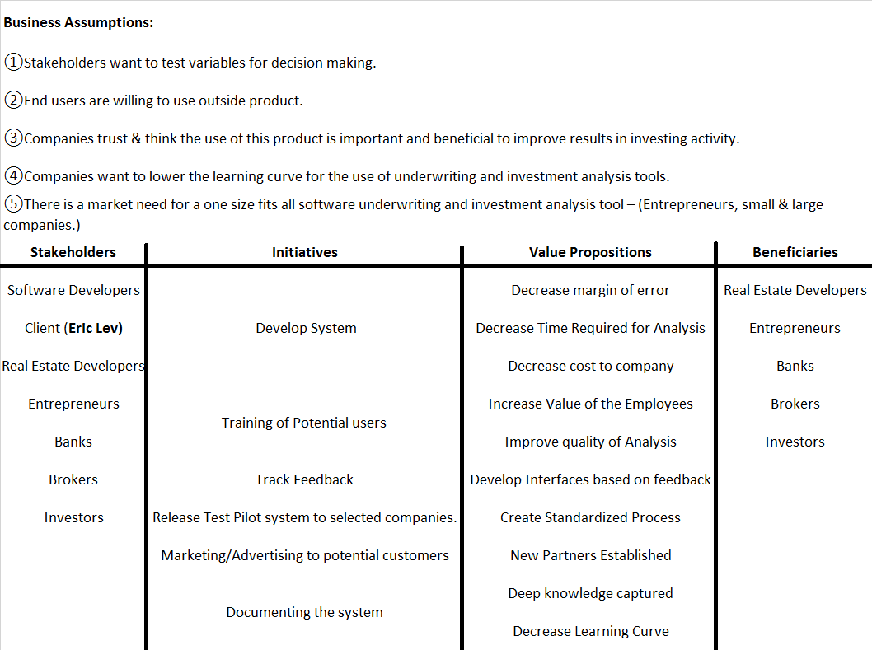
Shared Vision

Table 1: The Program Model

Benefits Chain
The major benefits that are expected from this project and have been identified in the Benefits chain diagram are:

- Improve the Quality of Analysis: In the current system, the setup of the financial real estate models is very time consuming and due to the urgency of most analysis often needs to mental mistakes made by the analysts during this process. In addition, the current reporting system is MS Excel based and is also time consuming and tedious to generate the desired report output. However the new system’s aim is to reduce the time and cost of setting up the analysis and generating the reports.
Current operational Time: 4 Hours
Expected Time from new System: 1 Hour

- Increase Value of Employees: The new system will enable analysts to focus more on the analysis of the real estate properties instead of using their mental energies to setup the model or to create and design new reports. The convenience of project documentation and trainings will help in raising the overall value of employees by lowering the learning curve where they will no longer need to program in order to run an analysis. This will increase the value of employees by increasing the value of their work.

- Creation of Standardized Process: Presently the real estate market has no standardized product to generate typical analytical reports for a variety of real estate property types. However the new system is designed and formulated in a fashion that it is expected to capture the market and setup a new industry standard that bankers, investors, and other real estate players can trust as accurate and critical to their investment activities.

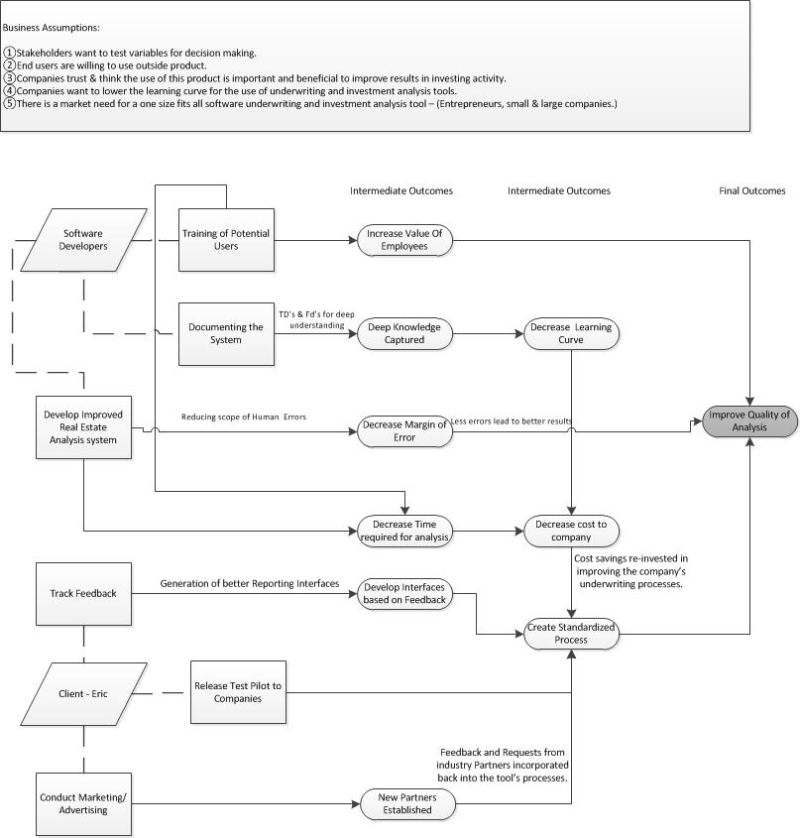
Figure 1: Benefits Chain Diagram of XL2 Project

System Capability Description
The system requested by the client is a software tool that will allow a user to set up real estate financial models based on different property types for the purpose of underwriting the real estate development and build of the project. While the client is currently running these models using Microsoft excel worksheets, the time and effort to set up these models for different property types is extremely labor intensive and prone to user errors as the process of creation is ad hoc and normally under time sensitive pressure to complete.

The target customer(s) are real estate development firms, banks, real estate entrepreneurs, and others who are interested in automating the effort to set up a real estate development underwriting model without having to understand the intricacies of how the worksheet fits in with each other, wants to save the time that would normally allocated to set up the model, wants to standardized the analysis process and reports produced by their underwriting analysts. The closest competitor of the system is a software tool called Argus Developer which is only targeted for large commercial real estate projects and does not have the capability to underwrite a variety of property types which this system is slated to perform.

System Boundary and Environment
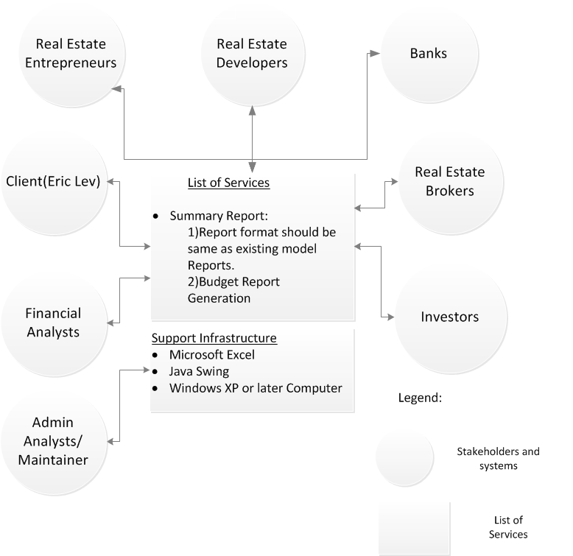

Figure 2: System Boundary and Environment Diagram of XL2 Project

System Transformation

Information on Current System

Infrastructure
The current infrastructure of the client’s system is very basic; Excel sheets are being used to store mathematical real estate data and formulas are used to generate complex reports based on that data.

Hardware:
- Desktops
- Laptops

Software tools:
- MS Excel
- Java Swing

Operating Systems:
- Windows

Artifacts
- Stakeholder’s Data Excel Sheets: Various Excel spreadsheets basically holding the Real Estate Data.
- Full Build Cash Flow Report

- Budget Report

Artifact | Description
Note Purchase.xls | Excel model for Note Purchases
Note Purchase (Hotel).xls | Excel model for Note Purchase of a hotel
Land Development 1.xls | Excel model for a Land Development deal
Hotel Renovation 1.xls | Excel model for a Hotel Renovation
Hotel Development 1.xls | Excel model for a new Hotel Development
Apartments.xls | Excel model forApartments

Current Business Workflow
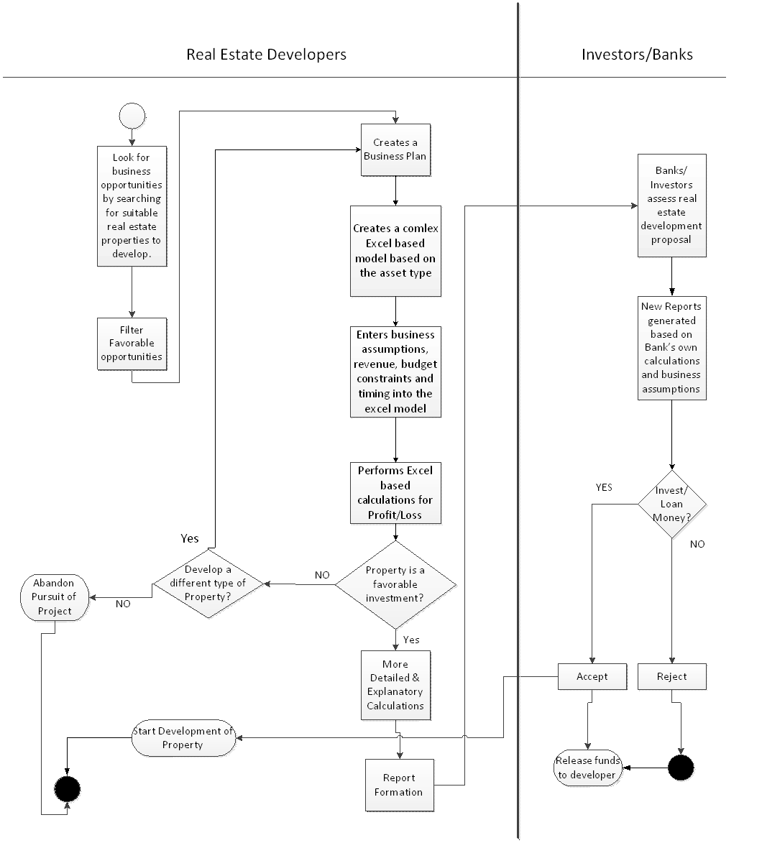
Figure 3: Business workflow Diagram

System Objectives, Constraints and Priorities

Capability Goals
Capability Goals | Priority Level
OC-1 The system has the capability to allow users to save reports at any stage (while inputting parameters or while feeding data) for future reference. | Must have
OC-2 System has basic options provided which could be understood and used by a beginner. | Should have
OC-3 System has the capability to create budgets for investments made. | Must have

Organizational Goals

OG-: Decrease the reporting time: Decrease the time needed to set up a real estate underwriting model from an average of 4 hours to 1 hour.
OG-2: Decrease the technical learning curve: Decrease the learning curve & knowledge needed to set up financial models to perform underwriting analysis.
OG-3: Standardize the underwriting reports: Standardize the underwriting reports used in an organization across the analysts employed in an organization.
OG-4: Standardize the way of calculations: Standardize the way calculations are performed for underwriting across the analysts employed in an organization enabling apples to apples comparison.
OG-5: Better utilization of Time for Analysis: Better utilize the time of analysts to enable them to repurpose the time for more thorough analysis of a deal.
OG-6: Reduce number of errors: Reduce the number of errors that occurs in the setup of a real estate model by creating a GUI that automates the model setup and creation process which accepts the data drivers from the user via standard data entry mechanisms (drop down list, checkbox, data fields etc.).

Constraints

CO-1: Windows as an Operating System: The new system must be able to run on Windows platform (Windows XP or later).
CO-2: Zero Monetary Budget: The selected NDI should be free, no monetary cost, or the user has the software that would enable the solution previously installed.
CO-3: Microsoft Excel as the main calculation and modeling engine: The client is currently using Excel to set up the underwriting models and run the financial calculations.
CO-4: Desktop Program: The system must run and be installed on the user’s computer. It cannot be a web based service where the sensitive data used for analysis could potentially be hosted outside of the company.

Relation to Current System
Table 2: Relation to Current System
Capabilities | Current System | New System
Roles and Responsibilities | The Real Estate Developers are also the only end users of the financial models.  In depth knowledge of excel formulas, macros required. | The Real Estate Developers, Banks, Entrepreneurs and all other stakeholders will be the end users. In depth knowledge of the inner workings of how the components of the excel model and how parts fit together and how to alter and change the model through the use of excel formulas and macros are not required to perform an underwriting analysis on a real estate project.
User Interactions | - Slow set up time of underwriting models  - Margin for errors made during setup  - Inconsistent analysis across property types and among different analysts  - Redundant model setup  - Analysts must know how to create models as well as run the models | - Faster set up time of underwriting models  - Less room for set up errors with layer or separation between modeling engine and user  - Use GUI instead of writing formulas and macros to run analysis  - Minimize redundancy of efforts in model setup  - Standardize underwriting analysis processes
Infrastructure | Microsoft Excel + excel files w/ PC | Java Swing GUI Interface(Form based) + Microsoft Excel + excel files w/ PC
Stakeholder Essentials and Amenities |  | - Time saved from analysis can be used on conducting more analysis  - Banks/Investors can do their own stress tests on the deal using the same model the real estate developer is using  - Common platform to perform underwriting analysis
Future Capabilities |  | - An advanced user option that will enable user to change more data drivers and increase the complexity of the real estate development deal.

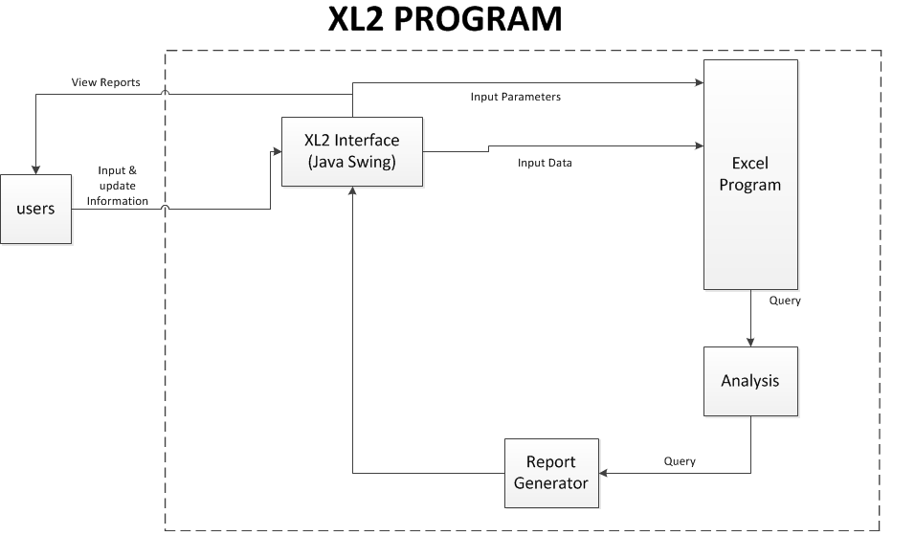
Proposed New Operational Concept

Element Relationship Diagram
Figure 4: Element Relationship Diagram

Business Workflows
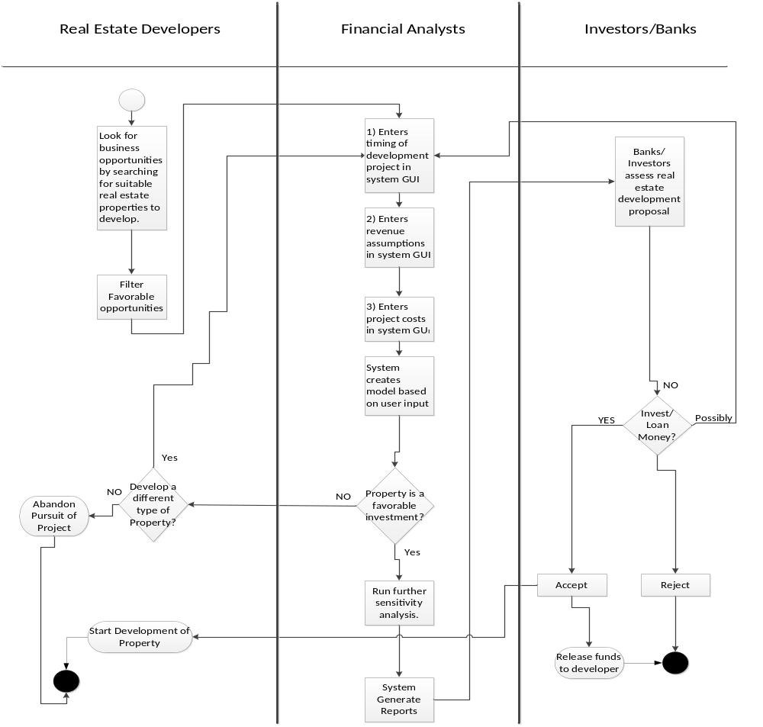Figure 5: Business Workflow Diagram

Organizational and Operational Implications

Organizational Transformations

- The need to provide users an easy to use underwriting analysis tool based on a graphical
User interface.

- The need to train users in an efficient way of using the new underwriting system,
Especially while setting up the parameters and attributes that define the data drivers for the real estate underwriting models.

- The elimination of the need to use existing time consuming process of generating reports by reducing the manual effort of entering the data in different cells across different worksheets.

- The need to hire analysts with programming and advanced excel modeling skills to perform underwriting analysis on a real estate property

Operational Transformations

- The option for analysts to use a graphical user interface to enter in the timing, revenue assumptions, and costs for a real estate development project.

- The elimination of the need for an analyst to copy and paste an excel file and manually alter the excel file to change one or two common driver attributes in order to perform a different but similar analysis.

